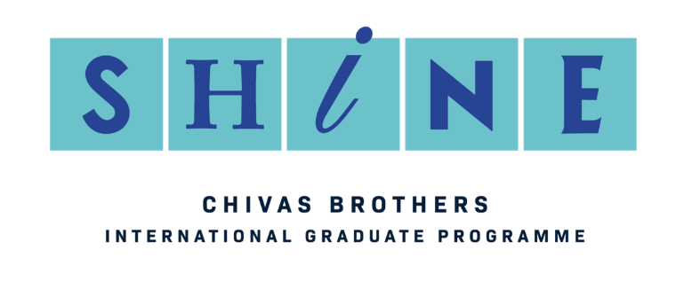

International Brand Ambassador
The Programme without Boundaries
Your Mission:

Become an International Brand Ambassador, representing a leading Scotch whisky or Gin brand, based internationally for up to two years. As an International Brand Ambassador, you will bring to life local marketing and trade initiatives to build consumer relevance and advocacy for your brand.

You will embody the very essence of your brand and play your part in opening up Scotch whisky and gin to new audiences through building unforgettable brand experiences. Key activities will include: conducting brand education sessions, building strong relevant relationships, and supporting brand marketing activity and events.

Location:

If successful, you will be assigned a placement in a key global market. Each year we have opportunities in Europe, Asia, Africa, Latin America and Australasia and the role will be based in the local Pernod Ricard Market Company.

A significant portion of the role will require time with customers to bring brand initiatives to life and may require a fair amount of evening or weekend work.

Reporting Lines:

The International Brand Ambassador will report directly to a marketing contact in the local market company. In addition, the Brand Ambassador will work closely with the International Programme Team within Chivas Brothers to ensure all brand market activations are implemented as required and to maintain a close link to the Brand Company.

Key Relationships:

Chivas Brothers | Market Company
Regular liaison with the:  - International Programme Team  - Global Brand Marketing team(s)  - International Brand Ambassador network  - Heritage team | Regular liaison with the:  - Marketing contact as line manager  - Sales team  - Customers / Bartenders / Consumers  - Media and key trade influencers

Key Responsibilities:
Brand Education & Mentoring
- Inspire and educate in-market sales team on the brand to generate interest and a robust understanding of qualities/characteristic/heritage.
- Execute mentoring programmes with key trade customers and in particular bartenders, bar managers and mixologists.
- Identify and conduct tastings/education for target groups of consumers / opinion leaders.

Trade Activation
- Build relationships with the outlet including customer and trade promotions, bar staff education and brand visibility.
- Working with the local sales and marketing teams, identify and target on-trade outlets for further development.
- Convert target consumers and influencers to the brand through tasting and brand education.
- Keep an on-going relationship with key flagship bars.
- Represent the brand at key events.
- Support the local team in the retail business where possible, with brand visibility, education and communication.

Brand Management/Insight
- Support implementation, tracking and evaluation of planned promotional activity in the trade.
- Propose, present and trial new brand initiatives, either international best practice or locally developed.
- Provision of market intelligence, investigating, analysing and reporting on key competitor activity and market dynamics to local brand team and Chivas Brothers.
- Highlight and promote the brand activities to relevant media/press contacts.
- Present the brand to trade and lifestyle press when/where appropriate opportunities arise.

Quarterly Reporting
- Complete quarterly report in line with Chivas Brothers format for circulation to PR Marketing and Chivas Brothers comprising of environment analysis, market trends, brand performance and specific ambassador activities.
- Provide regular best practice sharing.

Social Networking
- Develop and manage local social media campaigns, to target consumers, bar tenders and key contacts.
- Maintain strong social presence on and off line.
- Update with key events, brand activity and mentoring sessions and maintain and build relationships with key contacts.

Candidate Profile:

Essential experience/background

- Relevant work experience (please state exact dates) in sales or marketing post university; and / or a Master’s Degree.
- A commitment to living abroad for a minimum of two years and a desire to continue an international career beyond the programme.
- A self-confident, outgoing individual who actively enjoys building strong relationships.
- A self-starter who takes initiative to make things happen – entrepreneurial, enthusiastic, a ‘can do’ attitude.
- Maturity and professionalism – strikes an appropriate balance between leveraging conviviality and representing the brand and company in an appropriate manner.
- A passion for the bar scene and mixology, and therefore can inspire and connect with the bar community.
- A responsible attitude and approach towards alcohol.

Desirable experience/background
- University Degree in preferred in Business, Marketing or Languages.
- Experience of living or studying abroad.
- An interest in whisky or gin.
- Creative side hustles, interests, and hobbies.

Diversity & Inclusion:
In our culture, we want to create diverse teams in which our differences contribute to our success. Therefore, all are welcome at Pernod Ricard, regardless of your religious beliefs or personal choices on the consumption of alcohol.

In our business, we work together with industry members, civil society, governments, local authorities and UN bodies to promote responsible drinking.

